MEDIA RELEASE
FOR IMMEDIATE RELEASE
Press Contact: Natalie Groom
thewhistlinghens@gmail.com
+1 (240) 245-6848 (phone for media inquiries only, please)

September 21, 2022

ANNOUNCING WHISTLING HENS’ DEBUT ALBUM, REACTING TO THE LANDSCAPE
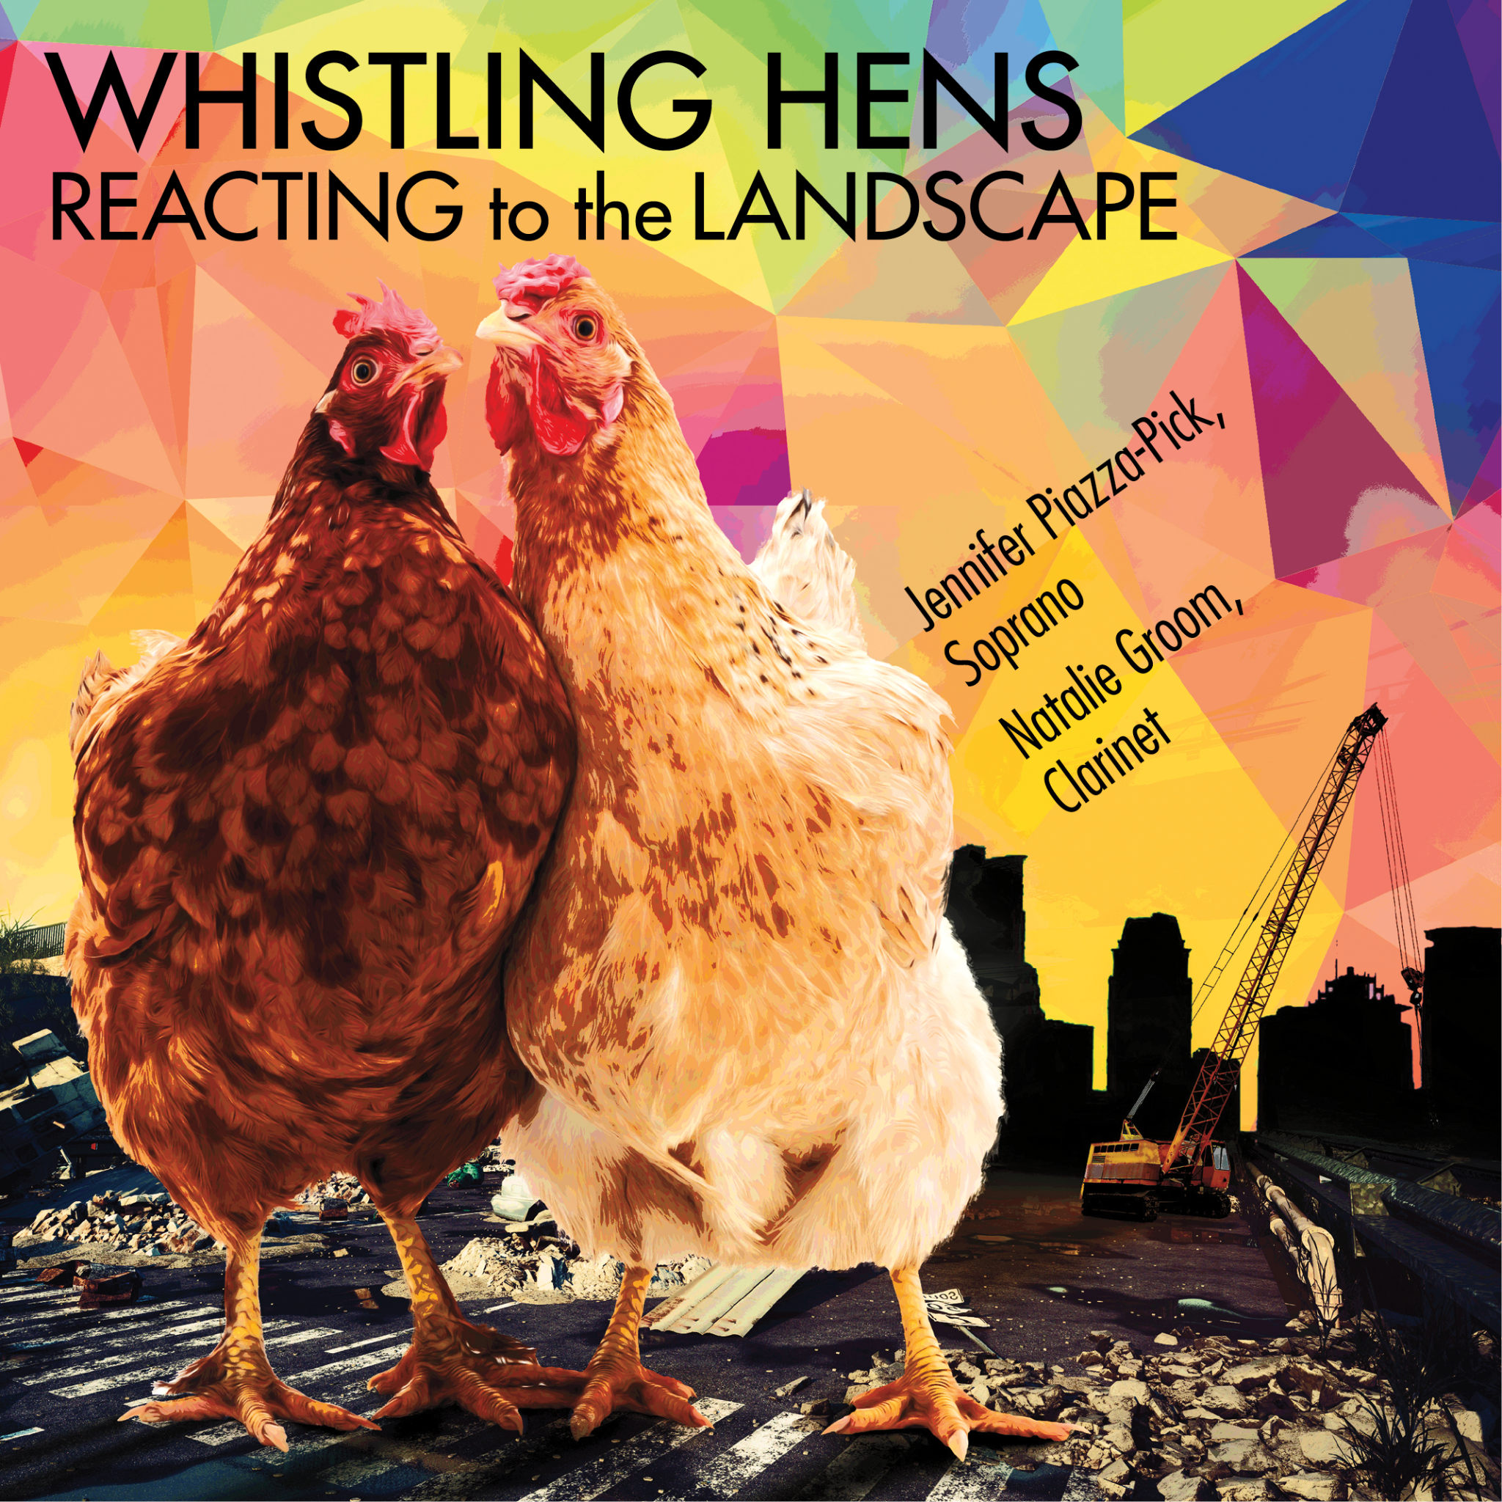
Whistling Hens’ debut album, Reacting to the Landscape, will be available for CD order and streaming starting October 1, 2022. This long-awaited project includes nine world premiere recordings of works by seven living American women composers: Victoria Bond, Ashi Day, Melika Fitzhugh, Cherise Leiter, Dannielle McBryan, Diana Rosenblum, and Jennifer Stevenson.

Showcasing five title commissions,
soprano Jennifer Piazza-Pick and clarinetist Natalie Groom masterfully present a wide variety of styles, sounds, and stories: a short dialog between a “joyfully callous” soprano spurning the clarinetist (Thursday); toe-tapping nonsense syllable scat sounds (Scat 2); a letter to a war-ridden country (Letter from Beirut); a mini play on themes of the resilience of women and girls (The Green Child); five American folk songs, from sassy to serene to saucy (American Folk Suite); an embrace of the warmth of womanly saints (A Woman Keeps Opening); an exploration of Eve’s first day on earth (Eve’s Diary); heartfelt observations of nature (Say I Am a River); and a final lullaby on the passing of loved ones (It’s Bedtime).

The album title, Reacting to the Landscape, comes from an interview in which former Baltimore Symphony Orchestra conductor Marin Alsop (the first female to lead a major orchestra in the U.S.) said,

“People ask why a course like this [for women conductors] is necessary, and I think it's a disingenuous question. It's only necessary because of the reality. It's not something I'm making up. I'm just reacting to the landscape...Because I have quite a thick skin, I don't mind being the one out front, trying to elbow my way in. But I think, as that person out front, it's important for me to create a pathway for people coming through. I don't want it to be so hard for the next generations.”

So why women composers? Why now? Whistling Hens is just reacting to the landscape.

MORE ABOUT THE HENS
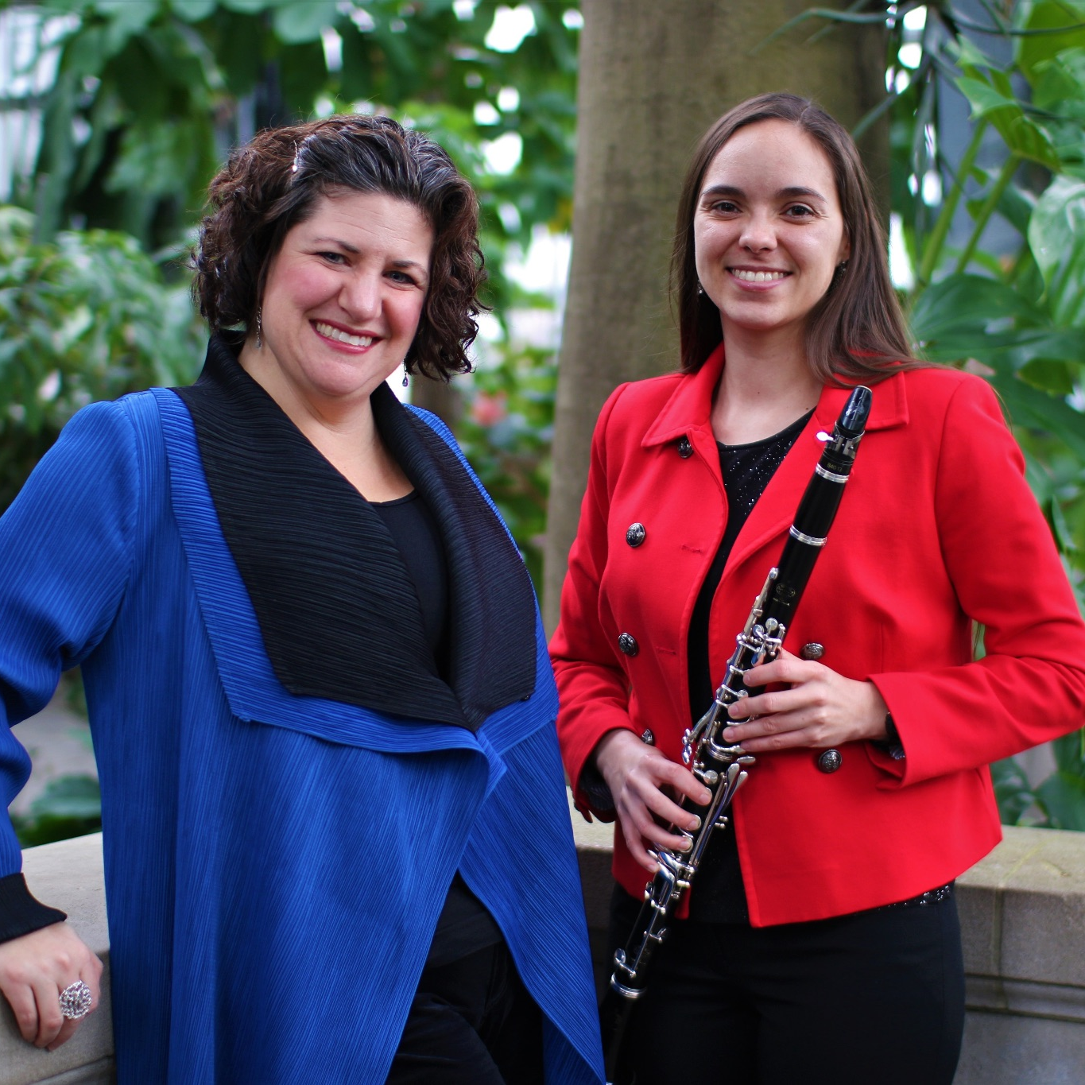
Whistling Hens was founded by soprano Jennifer Piazza-Pick and clarinetist Natalie Groom to perform and commission music by women composers and create a financially and artistically equitable future for women in music. The duo hatched at the centennial of a quote by a male music critic who said of Lili Boulanger in 1918, "women composers are at best whistling hens.” From 2018 to 2022, Whistling Hens has commissioned twelve works, seven transcriptions, and a women composer coloring book, as well as given fifteen premieres.

Whistling Hens’ work is essential because women have been historically excluded from composing, performing, publishing, and educational opportunities. Even into the 20th century, bigots have said women were intellectually incapable of composing good music and should focus on home life; women were discouraged or even banned from composing, and they weren’t afforded the same educational privileges as men. A complex and multi-faceted history, these discriminatory social norms forced some women to write under pseudonyms or not write at all. To correct against this exclusionary history, everyone must radically shift how they support women in the arts, and the Hens are doing this through targeted programming, educational outreach, and commissions. Their work invites listeners to reflect on the impact male privilege has had on traditional music programming and question the status quo of gender inequality in the classical music community.

HEAR THE HENS

#HeartheHens during album launch week across Maryland and D.C.!

Thursday, Sept. 29, 2022, 7:30 pm.
Linehan Concert Hall
University of Maryland, Baltimore County
┈Secure your ticket here┈

Friday, Sept. 30, 2022, 5:00 p.m.
Sidewalk Series
St. Thomas’ Parish, Washington, D.C.
┈Free event––more info here┈

Saturday, October 1, 2022
Album Release Date
┈Album available on major digital platforms┈
See whistlinghens.com/album for details.

Sunday, October 2, 2022, 3:00 p.m.
Collington Senior Living Retirement Community, Mitchellville, MD 20721
┈Free event, but limited capacity for outside guests
Contact Natalie Groom for instructions and directions┈

SAMPLE RECORDINGS
Cherise Leiter: American Folk Suite, Movements 3-5
Iris Szeghy: Meadow Song
Jenni Brandon: Multitudinous Stars and Spring Waters
Diana Rosenblum: Winter Rain

SUPPORT WHISTLING HENS’ WORK

Download and stream Reacting to the Landscape on major listening platforms starting October 1, 2022:
- Amazon
- Apple Music
- Pandora
- Spotify
See whistlinghens.com/album for details.

Subscribe to the Whistling Hens YouTube channel to hear more!

Explore the work of Whistling Hens at linktr.ee/whistlinghens.

Connect with the Hens on…
YouTube
Instagram
Facebook
Twitter
TikTok

#WhistlingHens #HearTheHens
#JenniferPiazzaPick #NatalieGroom
#MusicByWomen #WomenComposers #WomenInMusic #WomenInTheArts
#WomenInMusicHistory #HalfofHumanityComposers

Support future recording projects with a donation (non-tax deductible) at paypal.me/whistlinghens.

CONTACT:
Press Contact: Natalie Groom
thewhistlinghens@gmail.com
+1 (240) 245-6848 (phone for media inquiries only, please)

#######

